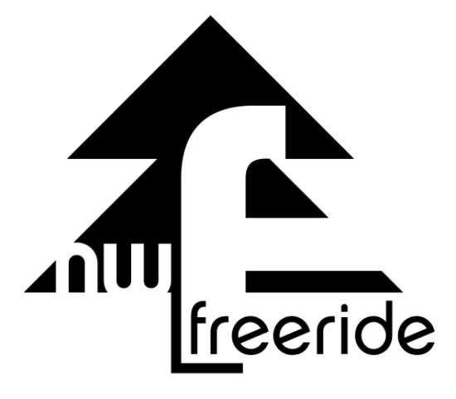

WWW.NWFreeride.org
EIN - 47-2407328
PO BOX 14 Graham, WA 98338

Name:________________________________________________________________________________

Address:____________________________________________
City: ______________________________ State:________________________________

Date of donation_____________________________ Donation amount___________________________

Cash Value of Donation______________________________
Description of donation:

___________________________________________________________________________________________________________________________________________________________________________________________________________________________________________________________________________________________________________________________________________________________________________________________________________________________________________________________________________________________________________________________________________________________________________________________________________________
Northwest Freeride is exempt from federal income taxes under Section 501(c)(3) of the Internal Revenue Code, therefore your qualifying donations are tax-deductible. Fill out this page for a record of your donation.
Northwest Freeride provided No goods or services in return for this gift.
Guidance from the IRS: IRS regulations require that before a donor may claim a tax deduction for a charitable contribution the donor must have a bank record or a written communication from a charity. The donor is responsible for obtaining the written gift acknowledgement for any single contribution of $250 or more and special rules for the gift acknowledgement apply when a donor gives a gift in excess of $75 and also receives something of more than insubstantial value from the charity in return

